ASSIGNMENT 1

<project xmlns=*"http://maven.apache.org/POM/4.0.0"*

xmlns:xsi=*"http://www.w3.org/2001/XMLSchema-instance"*

xsi:schemaLocation=*"http://maven.apache.org/POM/4.0.0 https://maven.apache.org/xsd/maven-4.0.0.xsd"*>

<modelVersion>4.0.0</modelVersion>

<groupId>restassuredassign</groupId>

<artifactId>restassuredassign</artifactId>

<version>0.0.1-SNAPSHOT</version>

<dependencies>

<dependency>

<groupId>io.rest-assured</groupId>

<artifactId>rest-assured</artifactId>

<version>4.4.0</version>

<scope>test</scope>

</dependency>

<dependency>

<groupId>io.cucumber</groupId>

<artifactId>cucumber-java</artifactId>

<version>6.11.0</version>

</dependency>

<dependency>

<groupId>io.cucumber</groupId>

<artifactId>cucumber-junit</artifactId>

<version>6.11.0</version>

<scope>test</scope>

</dependency>

<dependency>

<groupId>junit</groupId>

<artifactId>junit</artifactId>

<version>4.13.2</version>

<scope>test</scope>

</dependency>

<dependency>

<groupId>com.google.code.gson</groupId>

<artifactId>gson</artifactId>

<version>2.3.1</version>

</dependency>

<dependency>

<groupId>org.testng</groupId>

<artifactId>testng</artifactId>

<version>7.3.0</version>

<scope>test</scope>

</dependency>

<dependency>

<groupId>io.rest-assured</groupId>

<artifactId>rest-assured</artifactId>

<version>4.4.0</version>

<scope>test</scope>

</dependency>

<dependency>

<groupId>org.testng</groupId>

<artifactId>testng</artifactId>

<version>7.4.0</version>

<scope>test</scope>

</dependency>

<dependency>

<groupId>com.googlecode.json-simple</groupId>

<artifactId>json-simple</artifactId>

<version>1.1.1</version>

</dependency>

</dependencies>

</project>

Source code:

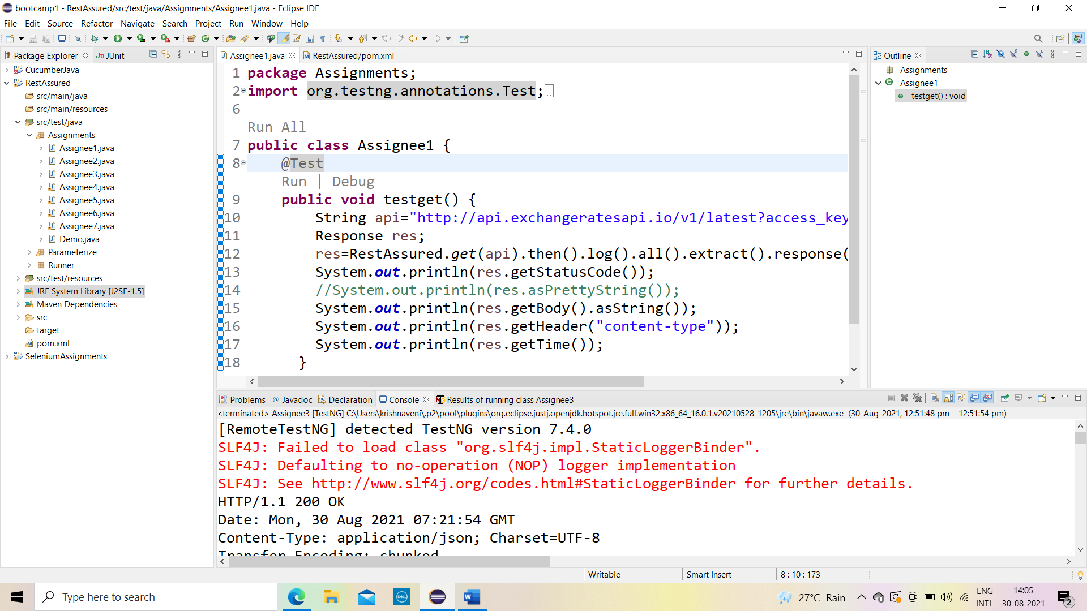

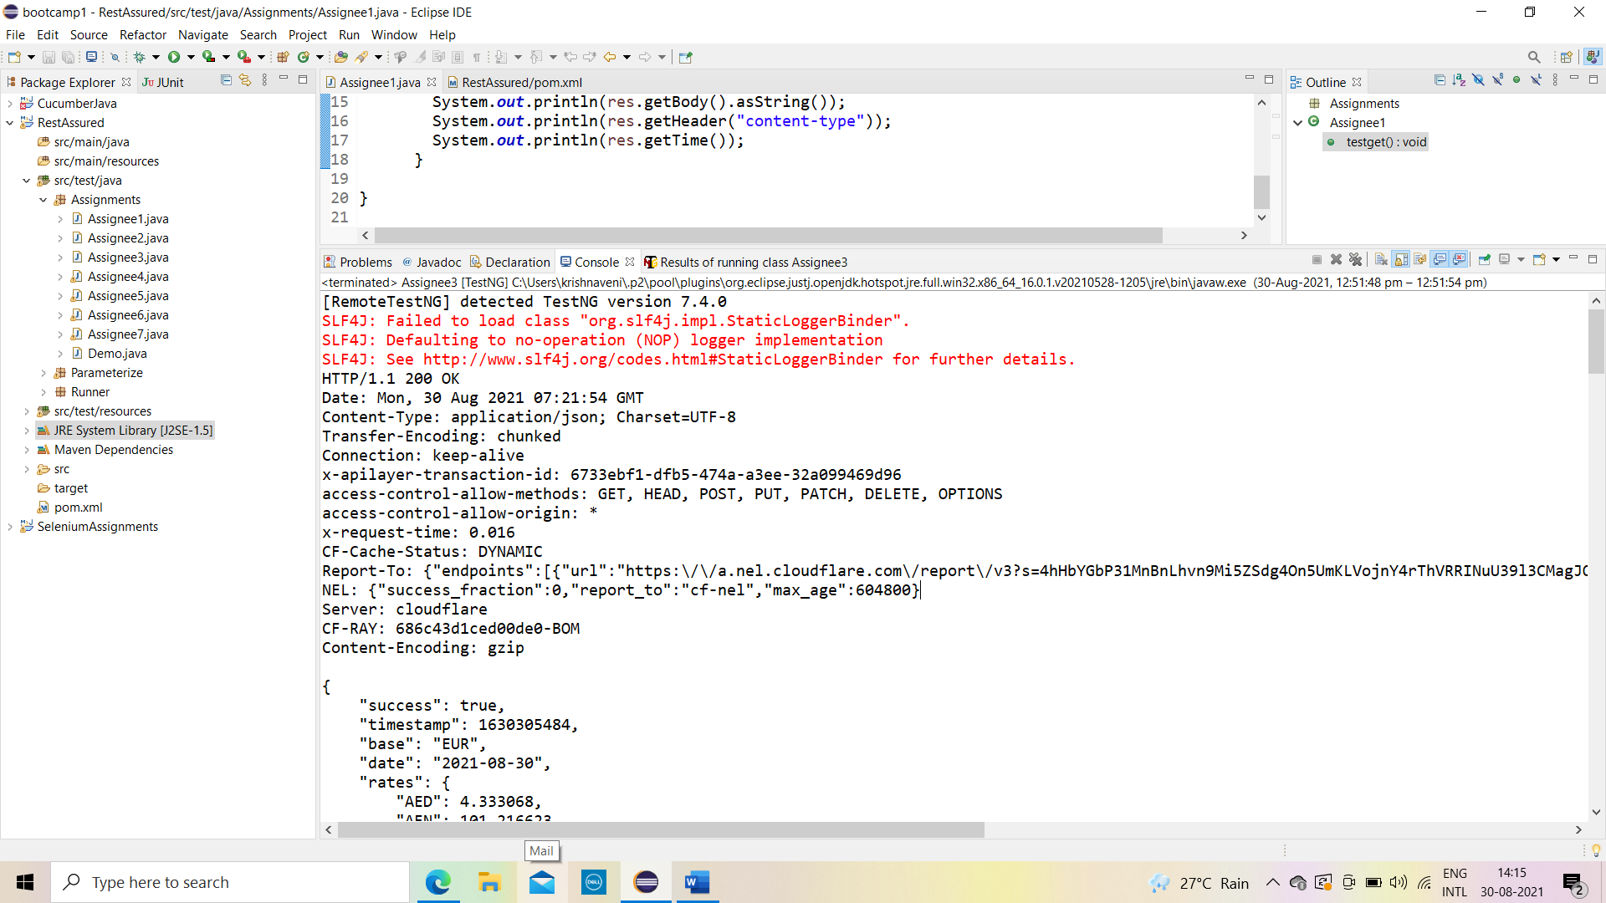

Output:

